### 

### **Gun Violence**

Spring 2023 CS506 Data Science

Team 5

Team members:

| Sai Surya Varshith | Nukala | [saisurya@bu.edu](mailto:saisurya@bu.edu) | Class of 2023 |
| --- | --- | --- | --- |
| Hitanshi | Jain | [hitanshi@bu.edu](mailto:hitanshi@bu.edu) | Class of 2023 |
| Yuhe | Bian | [yuheb@bu.edu](mailto:yuheb@bu.edu) | Class of 2023 |
| Peiying | Ye | [peiyingy@bu.edu](mailto:peiyingy@bu.edu) | Class of 2023 |

**Introduction**

**project goal & overview**

Project Goal: The main objective of this project is to delve into the factors contributing to gun violence in Boston's District 4 and draw comparisons with the rest of the city. The analysis will cover various aspects, such as police presence, poverty, population movements, and existing programs, with the ultimate aim of informing policies that can enhance the district and mitigate gun violence, especially among young individuals.

Project Overview: Initially, the project will concentrate on District 4 before broadening its scope to encompass the entire city of Boston. we will employ an array of data sources and conduct in-depth analyses to gain insight into the prevalence of gun violence in District 4 and juxtapose the findings with other areas in Boston. This approach will enable us to identify patterns and relationships between different variables, thereby assisting Councilor Worrell and other policymakers in making well-informed decisions to improve District 4 and address gun violence in the city. The project will involve examining police records, school discipline records, and community factors to identify patterns and relationships between different variables. Additionally, we will explore creative extensions to incorporate other relevant data sets to better understand the context of gun violence in the community. Ultimately, the findings from this project will help Councilor Worrell and other policymakers make informed decisions for improving District 4 and addressing gun violence in the city.

**The big picture/impact**

The insights derived from this project will enable Councilor Worrell, other policymakers, and stakeholders to devise focused and efficient approaches to tackle gun violence. By addressing the fundamental drivers of this issue, the proposed interventions are expected to foster safer communities, enhance social conditions, and improve the overall quality of life for residents in District 4 and throughout Boston.

In the long term, the impact of this project may transcend the local community, as its findings and policy suggestions could serve as a blueprint for other cities and districts grappling with similar challenges. The project's methodology in analyzing and addressing gun violence stands to enrich the wider discourse on violence prevention and community development, spurring additional research and initiatives in the field.

**Base Analysis**

**What is the rate of gun violence in District 4? How does this compare to the rest of the city?**

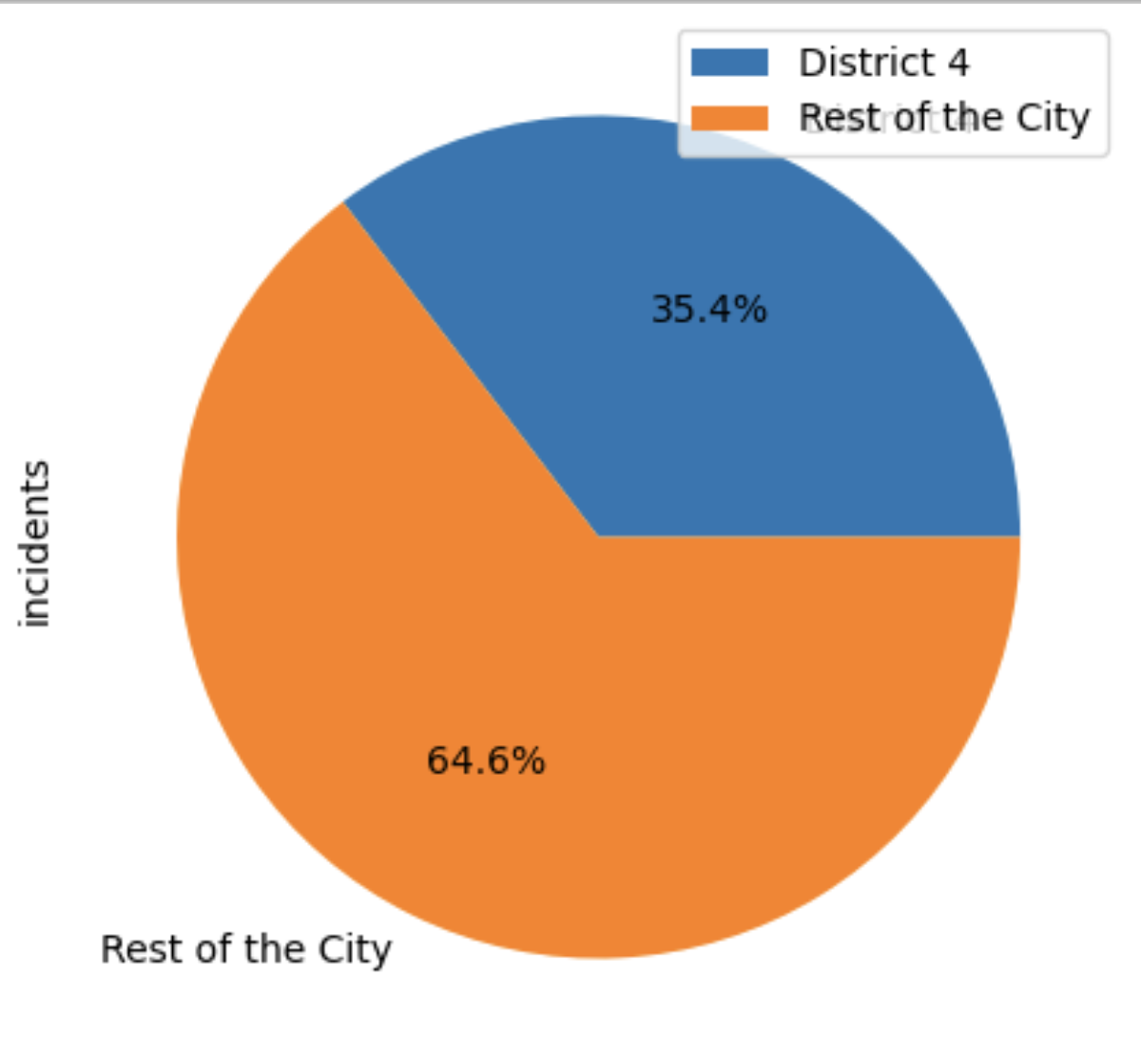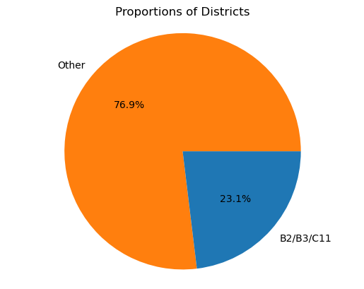

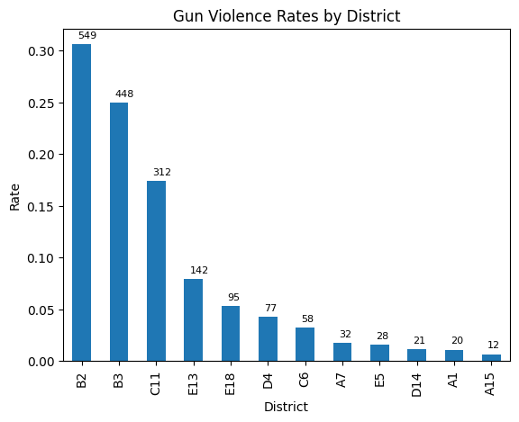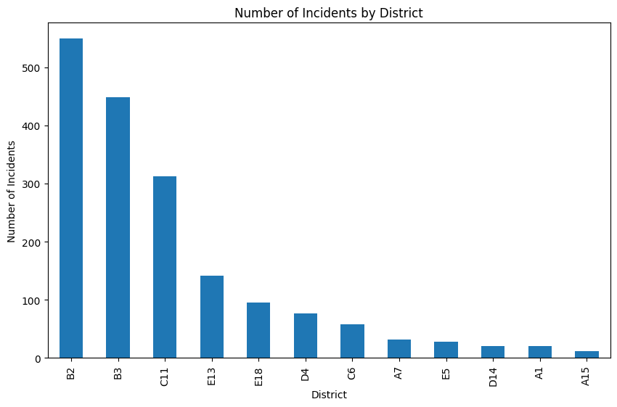

Given those graphs, we can see that B2, B3, and C11 in total are in charge of 23.1% of total shooting events in the Boston area. If we specify District 4, the proportion is even higher, which adds up to 35.4%. Given that District 4 by no means adds up to the area or population of 35% of Boston, we can see this incident percentage is really severe.

Are there patterns of violence in terms of location in District 4? How does this compare to the rest of the city?

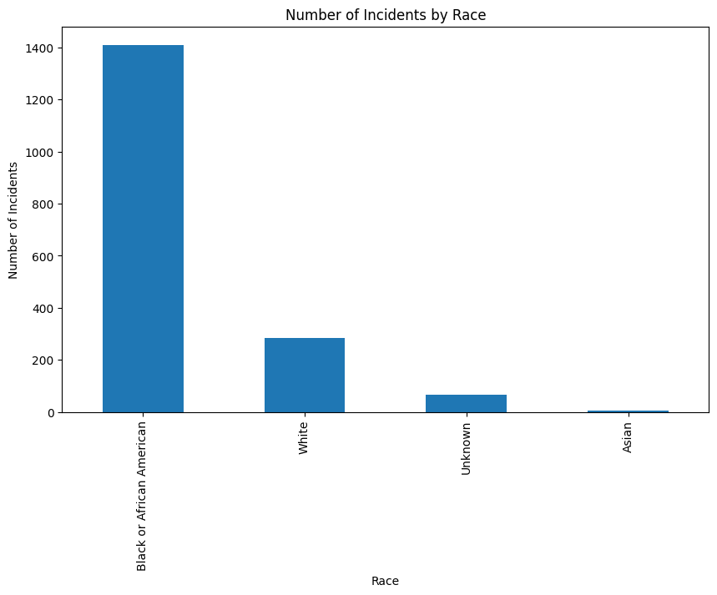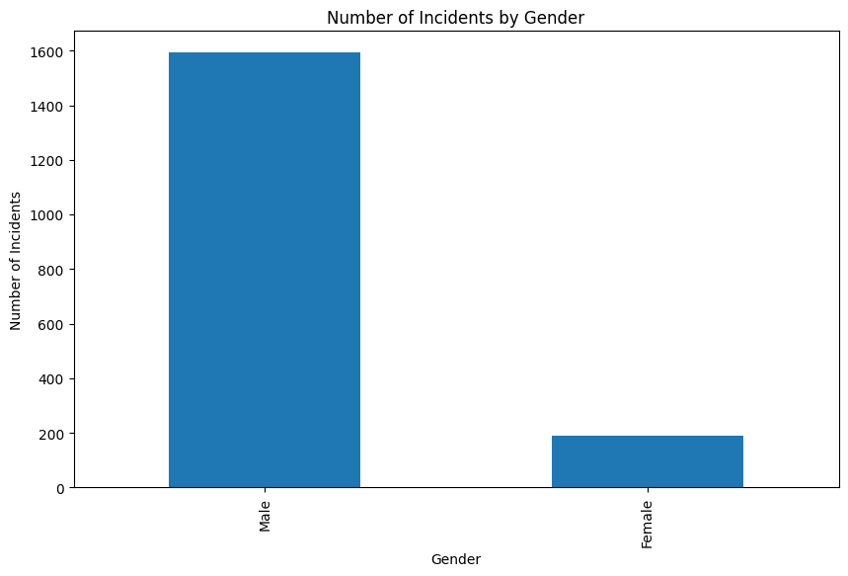

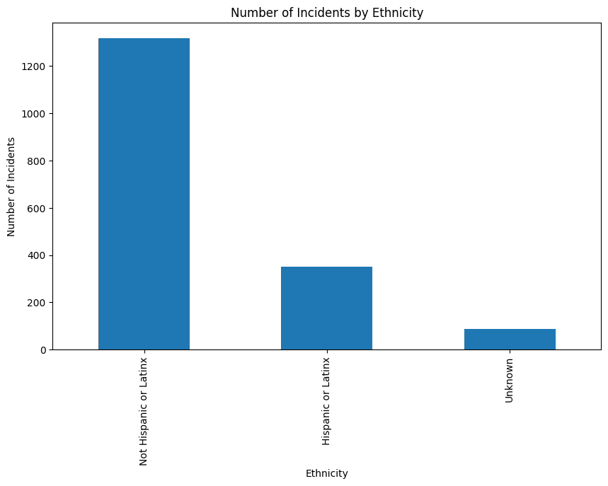

Here is the demographic report of the number of incidents by gender/race/ethnicity. We can see that in most cases, males are involved in gun violence. Also, in terms of race, black or African American are involved in the most gun violence, and in terms of ethnicity, Hispanic or Latinx are highly involved in gun violence.

Regarding the higher involvement of males in gun violence, this could be due to various societal and cultural factors. For example, there may be societal expectations or norms. Additionally, males may also be more likely to have access to firearms due to their participation in activities such as hunting or sport shooting.

Secondly, with respect to the higher involvement of black or African American individuals in gun violence, there are several potential contributing factors. One major factor is the persistent and systemic racism that black Americans face in various aspects of their lives, including in the criminal justice system.

Finally, the higher involvement of Hispanic or Latinx individuals in gun violence may also be related to social and economic factors.

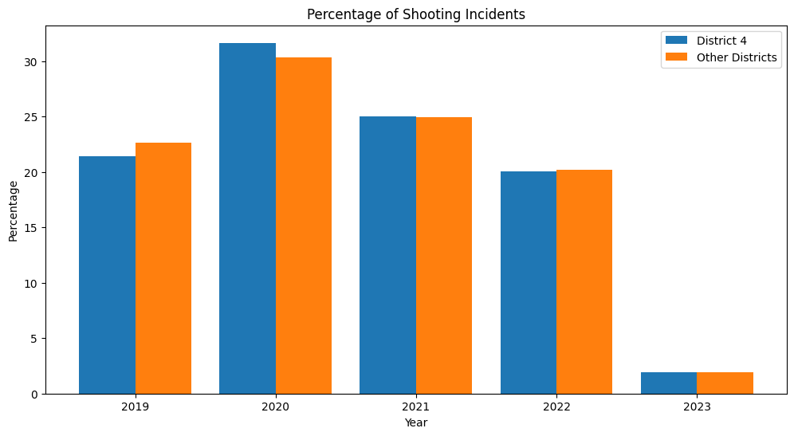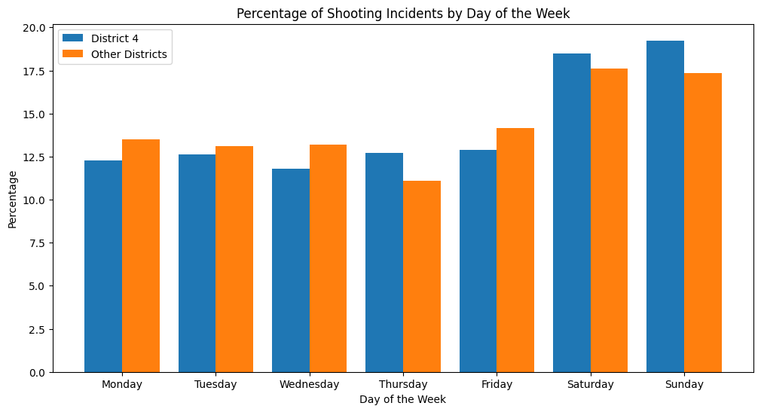

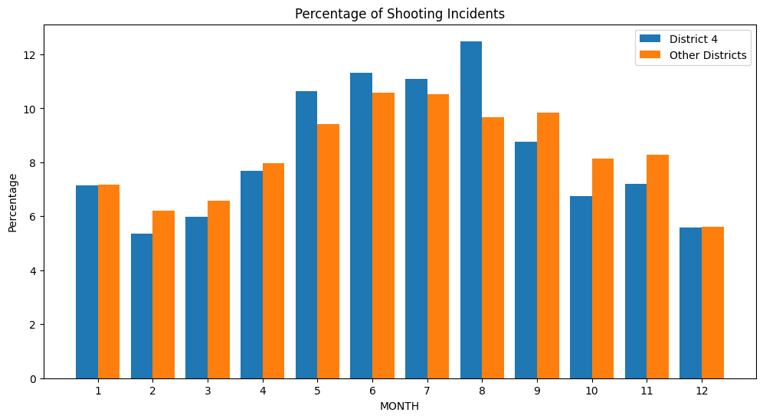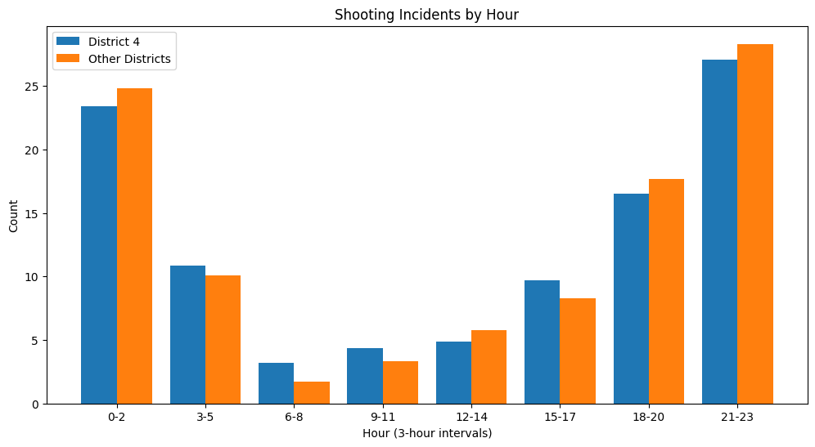

According to data from the Boston Police Department, the year 2020 saw an increase in shooting incidents compared to previous years in District 4.

In terms of smaller time scales, shooting incidents were more likely to occur on weekends than on weekdays. This may be due to factors such as increased social gatherings or higher rates of alcohol consumption during weekends. Additionally, shootings were more likely to occur during the summer months, which is a common trend across many cities. The warm weather and longer daylight hours during the summer months may contribute to increased outdoor activity, which in turn may increase the likelihood of violent incidents.

Regarding the time of day, shootings in Boston were more likely to occur during the nighttime hours. This trend is also common across many cities and may be attributed to factors such as lower visibility, fewer witnesses, and increased activity in certain areas during the nighttime.

**Are there patterns of violence in terms of location in District 4? How does this compare to the rest of the city?**

In VISUALIZATIONS - 3.0, 3.1,3.2,3.3 we have used combined [Crime Incidents Reports Datasets](https://data.boston.gov/dataset/crime-incident-reports-august-2015-to-date-source-new-system) from (2015-Present).

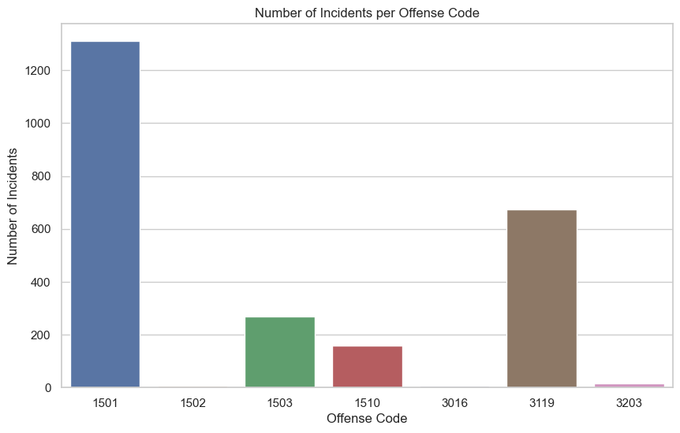

**VISUALIZATION - 3.0**

**Counts of Gun Violence Offenses in District 4**

3203: FIREARM/WEAPON - LOST (15)

1510: WEAPON - FIREARM - OTHER VIOLATION (175)

3016: FIREARM/WEAPON - ACCIDENTAL INJURY / DEATH (7)

3119: FIREARM/WEAPON - FOUND OR CONFISCATED (724)

1501: WEAPON - FIREARM - CARRYING / POSSESSING, ETC (1454)

1502: WEAPON - FIREARM - SALE / TRAFFICKING (8)

1503: WEAPON - OTHER - CARRYING / POSSESSING, ETC (318)

**Description of the Visualisation:-** Visualisation 3.0 presents a the number of incidents per offense code in the dataset. Each bar represents an offense code, and the height of the bar represents the number of incidents associated with that offense code. The bar graph shows that 1501: "WEAPON - FIREARM - CARRYING / POSSESSING, ETC." has the highest number (1454) of incidents while 3016: FIREARM/WEAPON - ACCIDENTAL INJURY / DEATH has the least number (7) of incidents.

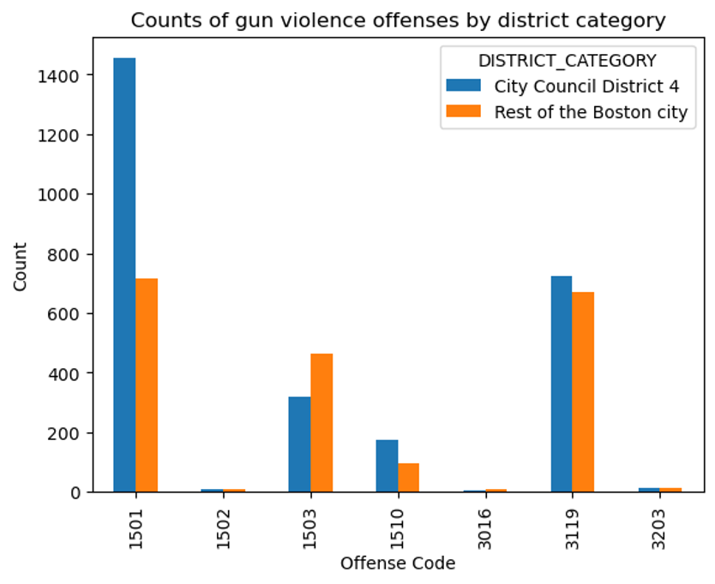

**VISUALIZATION - 3.1**

**Counts of Gun Violence Offenses in Rest of the Boston**

3203: FIREARM/WEAPON - LOST (15)

1510: WEAPON - FIREARM - OTHER VIOLATION (98)

3016: FIREARM/WEAPON - ACCIDENTAL INJURY / DEATH (11)

3119: FIREARM/WEAPON - FOUND OR CONFISCATED (701)

1501: WEAPON - FIREARM - CARRYING / POSSESSING, ETC (749)

1502: WEAPON - FIREARM - SALE / TRAFFICKING (8)

1503: WEAPON - OTHER - CARRYING / POSSESSING, ETC (476)

**Description of the Visualisation:-** Visualisation 3.1 presents a comparison between gun violence offenses in District 4 and the rest of Boston. The data has been filtered to include only gun violence-related offenses and includes a total of seven offense codes as shown above. The visualization shows the number of offenses for each code in both District 4 and the rest of Boston. District 4 has a higher number of gun violence offenses in most categories, with the exception of "WEAPON - FIREARM - OTHER VIOLATION," which has a higher count in the rest of Boston. The offense with the highest number of incidents in both District 4 and the rest of Boston is "WEAPON - FIREARM - CARRYING / POSSESSING, ETC," with 1454 and 749 incidents, respectively. This visualization helps to highlight the areas in which gun violence is most prevalent in Boston and can be used to inform targeted interventions and prevention efforts.

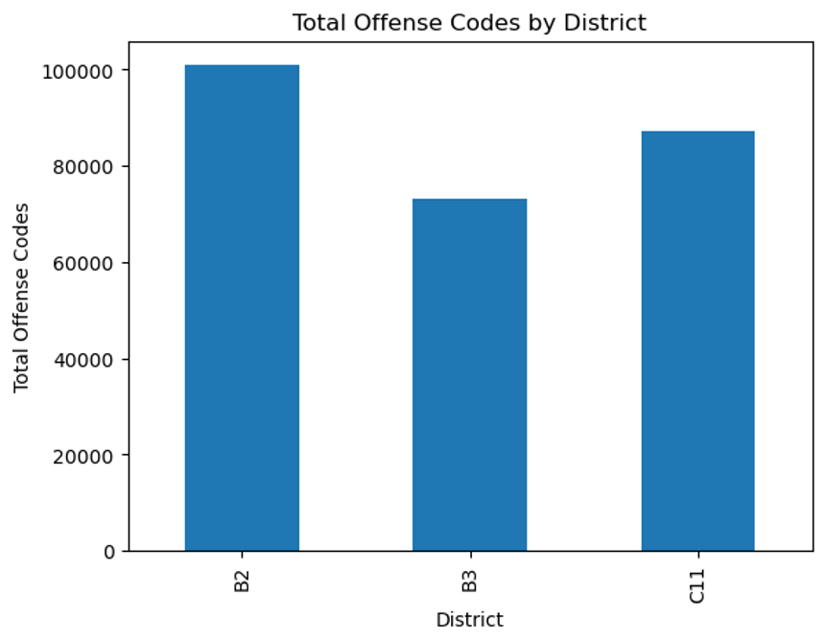

**VISUALIZATION - 3.2**

| **DISTRICT** | **TOTAL COUNT OF OFFENSES FROM (2015- PRESENT)** |
| --- | --- |
| B2 | 100896 |
| B3 | 73067 |
| C11 | 87158 |

**Description of the Visualisation:-** Visualisation 3.2 presents the total count of offenses in three Boston police districts (B2, B3, and C11) from 2015 to the present. Unlike Visualisation 3.1, this visualization includes all crime incidents, not just those related to gun violence. The data shows that B2 (Roxbury) has the highest number of offenses with 100,896 incidents recorded, while B3 (Mattapan) has the least number of offenses with 73,067 incidents. C11 falls in the middle with 87,158 incidents. This visualization provides an overview of the crime situation in these three districts and can be used to inform resource allocation and policing strategies to address the areas with the highest crime rates.

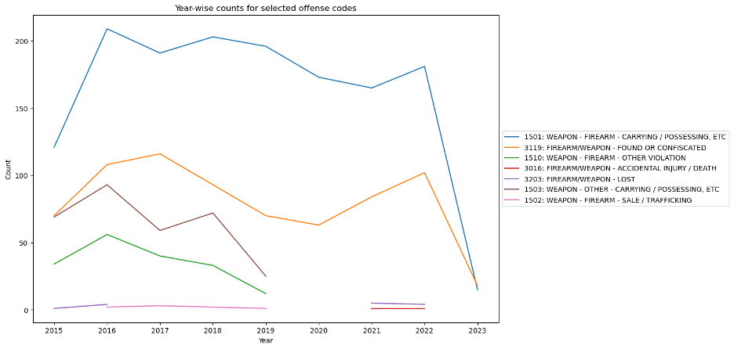

**VISUALIZATION - 3.3**

**Description of the Visualisation:-**Visualisation 3.3 presents a year-wise count of gun violence-related offenses in District 2 in Boston. The data is filtered to include seven specific offense codes related to gun violence. Each code's count is presented on the y-axis, while the x-axis shows the year of the incident. The visualization provides a clear overview of the number of gun violence incidents recorded each year for the seven offense codes in District 2. It can be used to identify trends and patterns in gun violence-related incidents in the district over time. Policymakers and law enforcement can use this information to allocate resources and design interventions to address the specific types of gun violence offenses that are most prevalent in the district.

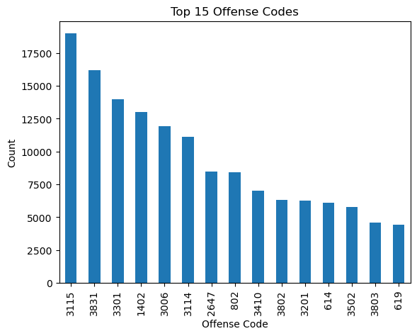

**VISUALIZATION - 3.4**

**Description of the Visualisation:-**Visualization 3.4 presents a bar plot of the top 15 offense codes in District 4 in Boston based on the number of reported incidents. The visualization shows the count of incidents on the y-axis and the offense codes on the x-axis. The offense codes and their corresponding count of incidents are as follows:

3115: INVESTIGATE PERSON (18,978)

3831: M/V - LEAVING SCENE - PROPERTY DAMAGE (16,182)

3301: VERBAL DISPUTE (13,972)

1402: VANDALISM (12,984)

3006: SICK/INJURED/MEDICAL - PERSON (11,939)

3114: INVESTIGATE PROPERTY (11,123)

2647: THREATS TO DO BODILY HARM (8,491)

802: ASSAULT SIMPLE - BATTERY (8,397)

3410: TOWED MOTOR VEHICLE (7,025)

3802: M/V ACCIDENT - PROPERTY DAMAGE (6,326)

3201: PROPERTY - LOST (6,257)

614: LARCENY THEFT FROM MV - NON-ACCESSORY (6,123)

3502: MISSING PERSON - LOCATED (5,760)

3803: M/V ACCIDENT - PERSONAL INJURY (4,605)

619: LARCENY ALL OTHERS (4,422)

The visualization provides an overview of the most common offenses in District 4 in Boston, with a focus on non-violent offenses such as investigating persons and property, leaving the scene of a motor vehicle accident, and property-related offenses such as theft and vandalism. The visualization highlights the importance of addressing these non-violent offenses in addition to violent crimes in efforts to improve public safety and quality of life in District 4.

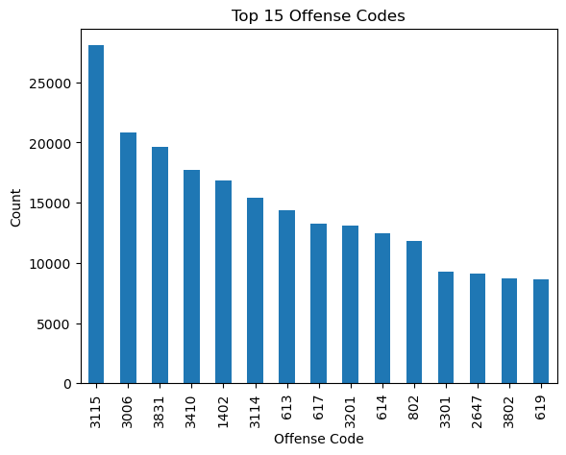

**VISUALIZATION - 3.3**

**Description of the Visualisation:-**

Visualization 3.5 presents a bar graph of the top 15 offense code counts for the rest of Boston, excluding City Council District 4. The counts and offense codes are as follows:

OFFENSE_CODE COUNT OFFENSE_DESCRIPTION

3115 28076 INVESTIGATE PERSON

3006 20853 SICK/INJURED/MEDICAL - PERSON

3831 19673 M/V - LEAVING SCENE - PROPERTY DAMAGE

3410 17732 TOWED MOTOR VEHICLE

1402 16829 VANDALISM

3114 15430 INVESTIGATE PROPERTY

613 14406 LARCENY SHOPLIFTING

617 13252 LARCENY THEFT FROM BUILDING

3201 13122 PROPERTY - LOST

614 12460 LARCENY THEFT FROM MV - NON-ACCESSORY

802 11814 ASSAULT SIMPLE - BATTERY

3301 9246 VERBAL DISPUTE

2647 9088 THREATS TO DO BODILY HARM

3802 8741 M/V ACCIDENT - PROPERTY DAMAGE

619 8656 LARCENY ALL OTHERS

Visualization 3.5 provides insights into the most common types of offenses occurring in Boston, outside of City Council District 4. The highest count is for "Investigate Person" offenses, followed by "Sick/Injured/Medical - Person" and "M/V - Leaving Scene - Property Damage." This visualization highlights the prevalence of different crime types in the area and can help policymakers, law enforcement, and community members better understand and address public safety concerns

**Extension Analysis**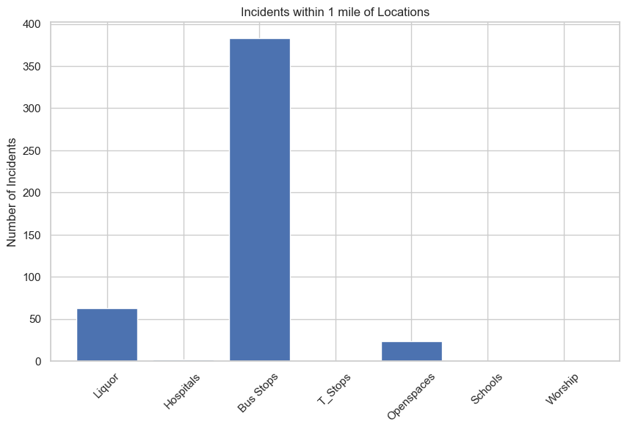

Liquor Stores: 63

Hospitals: 2

Bus Stops: 383

T-Stops: 0

Open Spaces: 24

Schools: 0

Places of Worship: 0

* The plot shows the total number of incidents within a 1-mile radius of different types of locations such as liquor stores, hospitals, bus stops, T stops (train stops), open spaces, schools, and places of worship.
* It can be seen that the bus stops have the highest number of incidents happening within 1 mile of radius.

**Analysis of Dropout Rate**

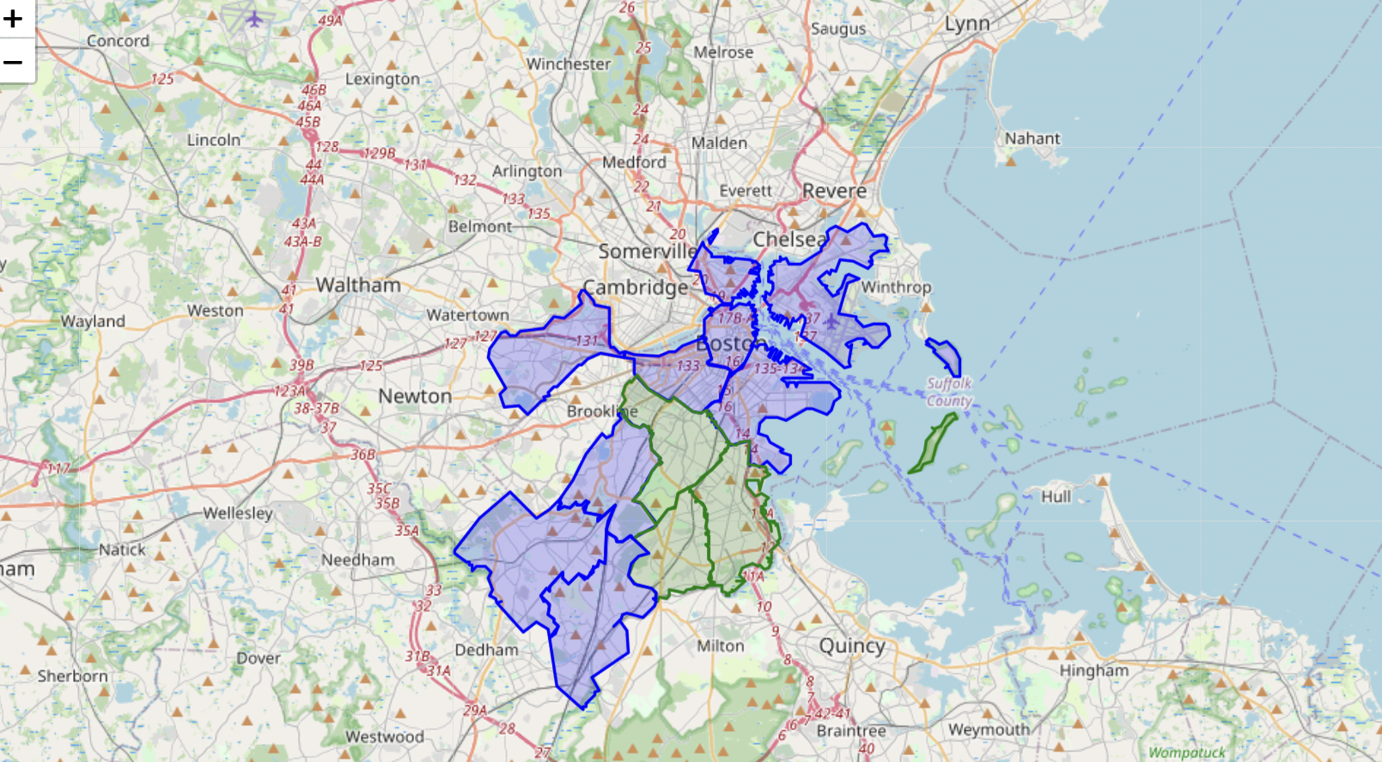

In the above plot blue districts are rest of the boston districts and green parts are District 4.

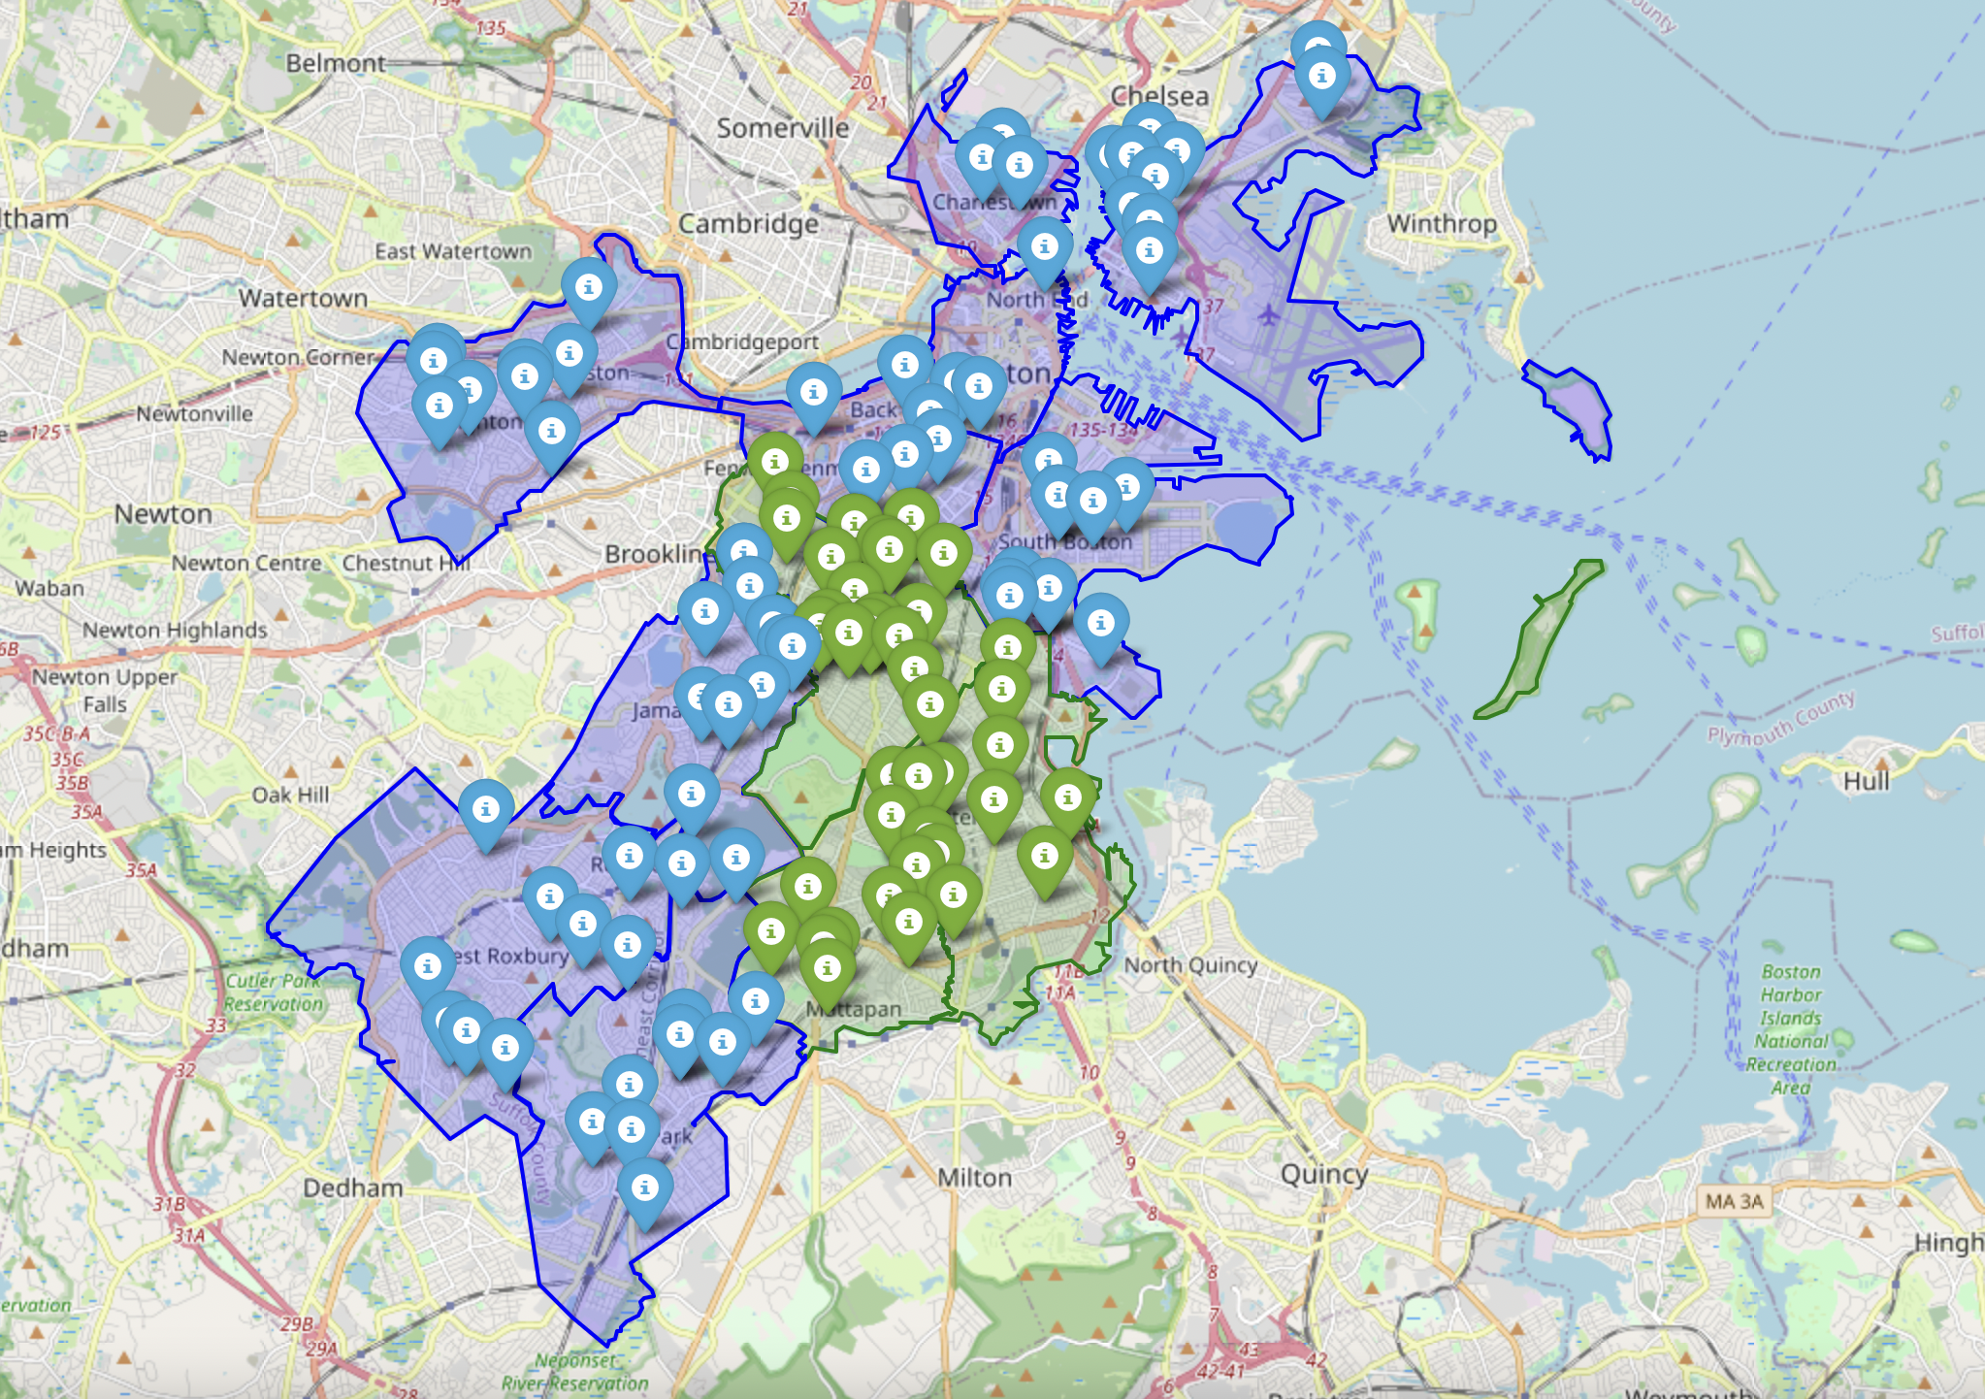

In the above graph, green markers show schools from D4, and blue markers are the schools from rest of the Boston.

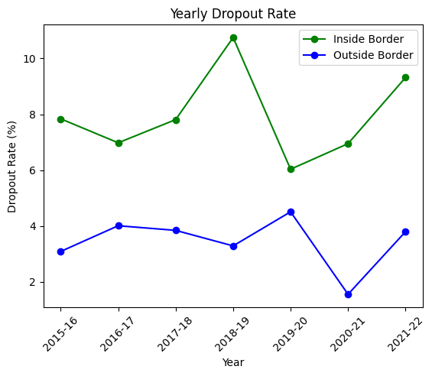

* The graph shows that the dropout rate has been consistently higher for schools outside the Boston border than for schools inside the border during the entire period from 2015-16 to 2021-22. The dropout rate for schools inside the border fluctuated between 2% and 4%, while the dropout rate for schools outside the border was between 4% and 10%.
* The trend for both groups appears to be stable, with only minor variations from year to year. It is worth noting that there is a sharp drop in the dropout rate for schools inside the border in 2019-20, which may be due to changes in school policies, external factors, or reporting methods.

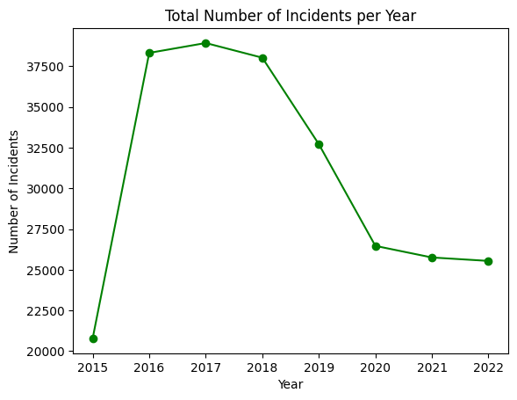

* The plot provides an overview of the total number of incidents over the years and shows the trend in the count of incidents.
* The result obtained shows that the number of incidents was highest in the year 2017 and then there has been a subsequent decrement in the count of incidents till the year 2022.

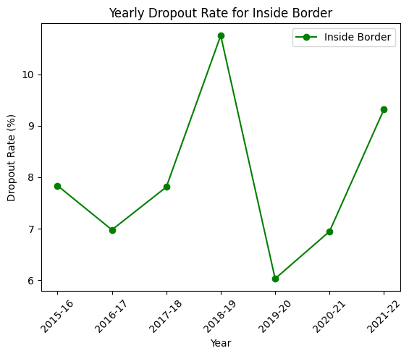

* The plot shows the trend in yearly dropout rates for the Inside Border over time.
* Based on the graph, it appears that the dropout rate for the Inside Border increased over time, with a peak in the 2018-19 year and then decline in the years following.

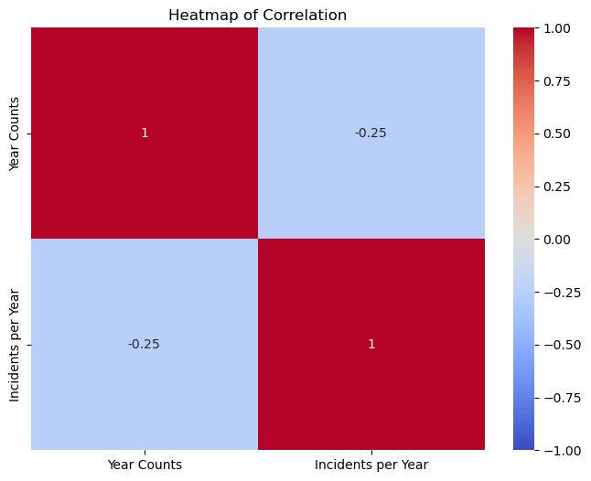

According to this heat map, we can tell that the yearly school dropout rate has a weak negative correlation with firearm offenses. Where the correlation coefficient is -0.250194.

**Analysis of Streetlight Correlation**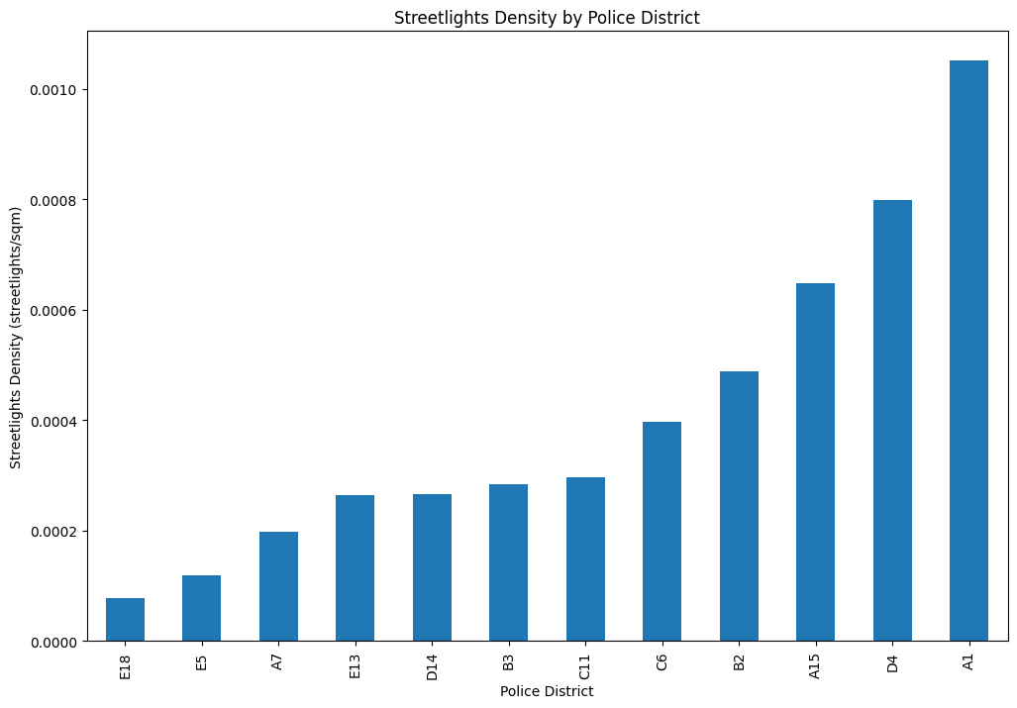

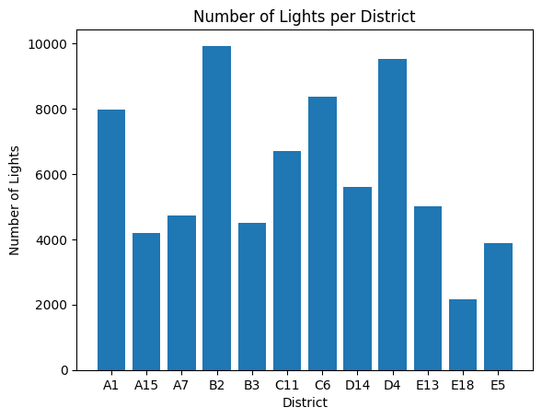

* In this part, we tried to figure out the correlation between streetlights and shooting incidents, so first, we calculated the number of lights per district.

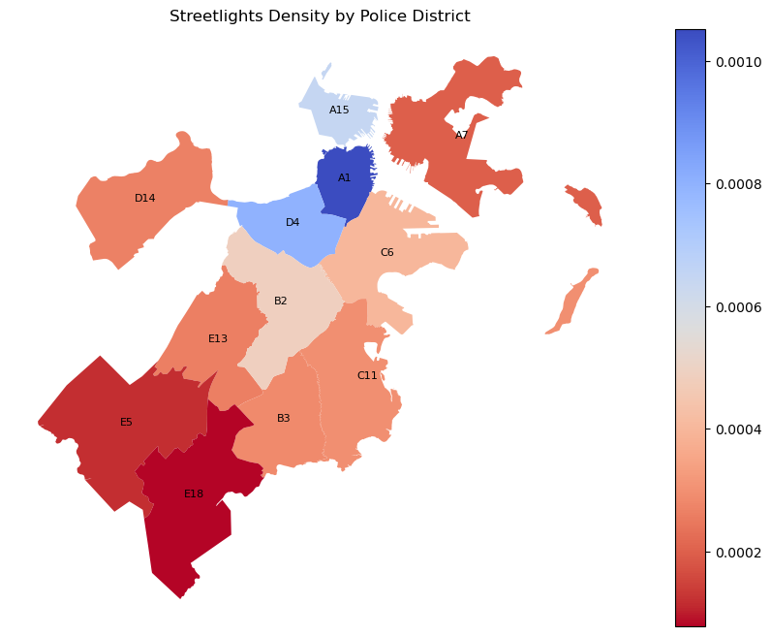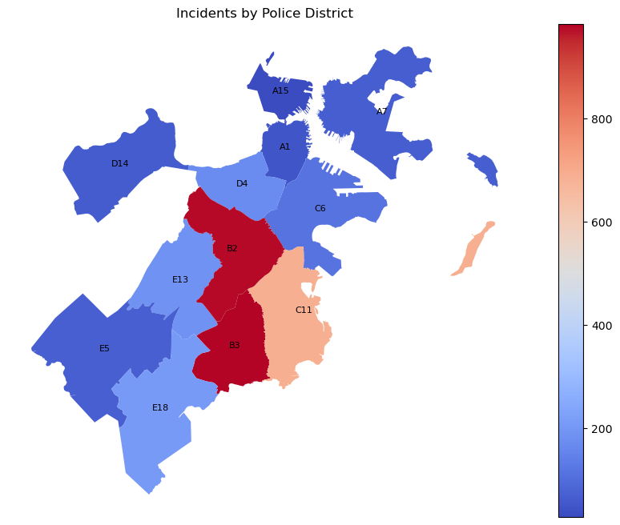

* To get a better understanding of streetlights, we then calculated the density of streetlights per area and got a heatmap
* We can see that for police districts in District 4, B2, B3, and C11, the streetlight density is not that high, which might be correlated with a high shooting rate, the dimmer situation is more likely to cover crime scenes.

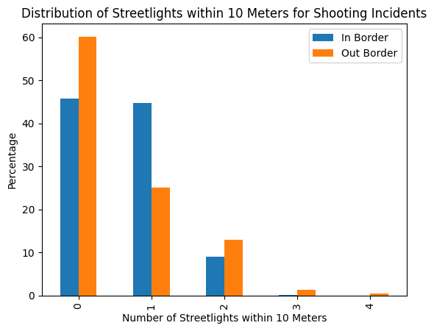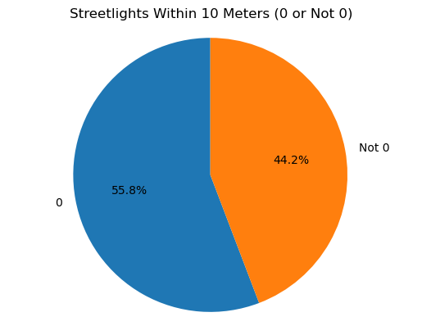

* We then calculated the number of streetlights within 10 meters of shooting crime incidents, and compared that number within District 4 or not.
* In general, we can see most crimes happen where there is zero or only one streetlight in proximity.

**Attendance Rate Analysis**

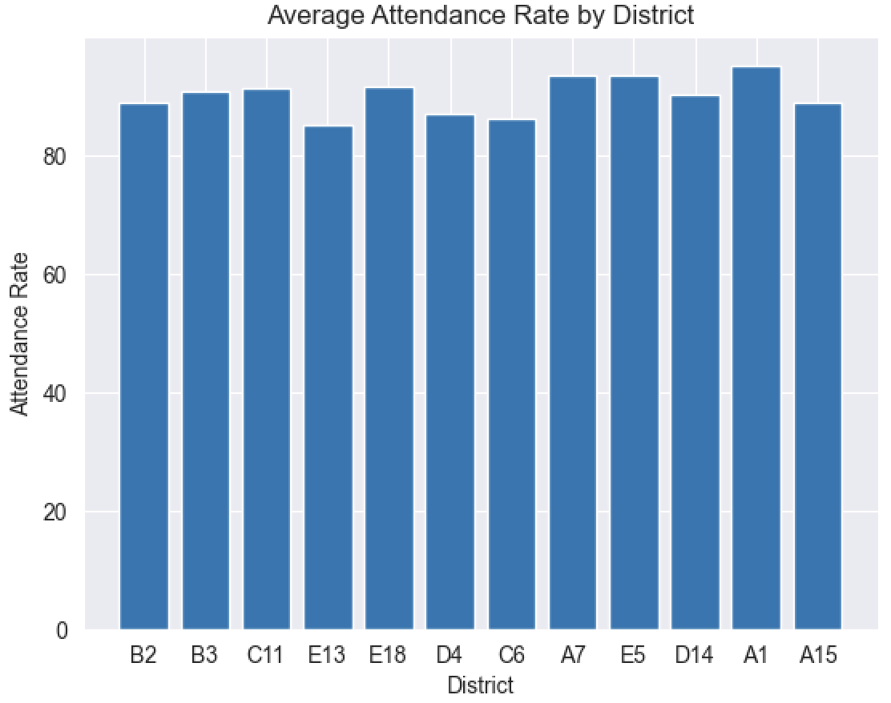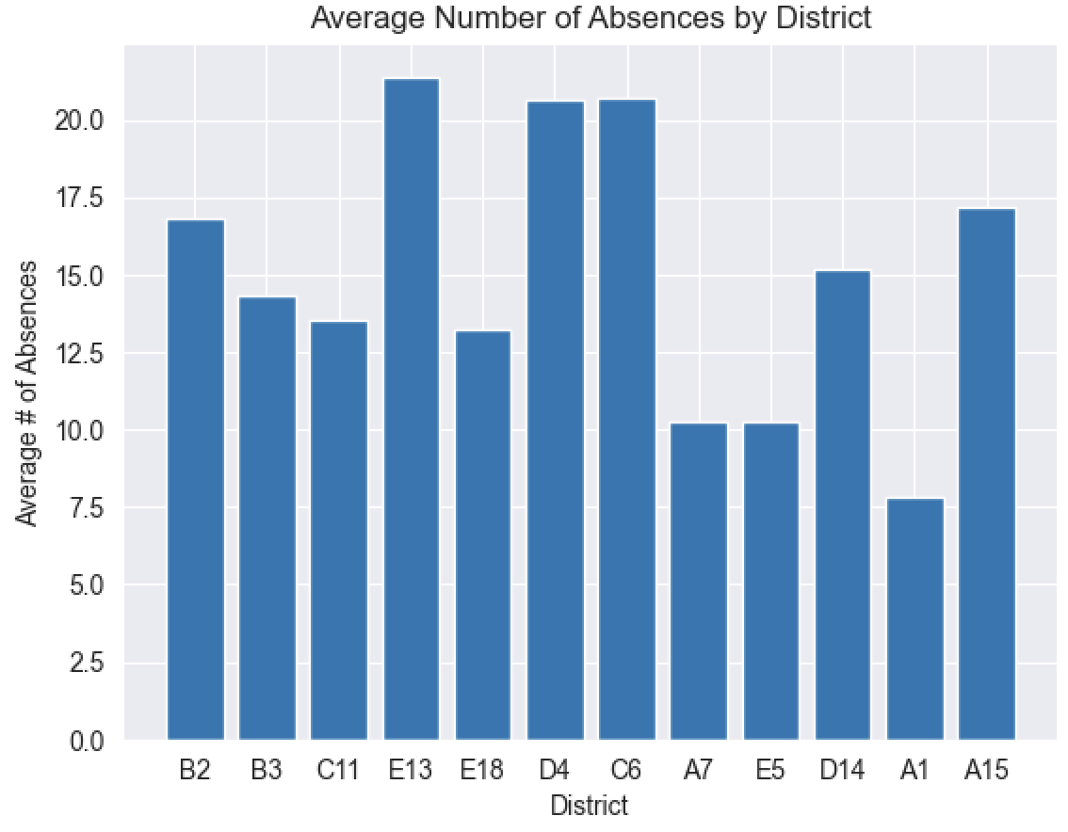

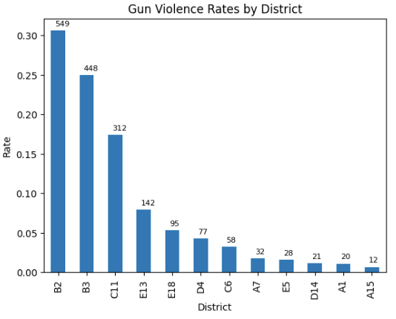

The first plot shows the average attendance rate by the district in Boston. It indicates the districts where students have a higher rate of attendance. The district with the highest average attendance rate can be identified as the district with the tallest bar on the plot which is A1 E5 A7

The second plot shows the average number of absences by district in Boston. It indicates the districts where students have a higher rate of absence. The district with the highest average number of absences can be identified as the district with the tallest bar on the plot which is E13 C6 D4.

The third shows the average number of chronically absent students (students who have missed 10% or more of school days) by the district in Boston. The plot indicates the districts where students have a higher rate of chronic absenteeism. The district with the highest average number of chronically absent students can be identified as the district with the tallest bar on the plot which is D4 C6 E13. Now if we compare it with the Gun Violence rate by district, we can find that A1 has the lowest Gun Violence rate, also it has the highest average attendance rate, lowest the average number of absences, and the lowest average number of chronically absent students. And we can see all of the areas that have a 0.05 or higher Gun Violence rate, in those areas, all of them have a relatively lower average attendance rate**,** higher average number of absences, and higher average number of chronically absent students.

**Conclusion**

**Basic Analysis**

* It can be seen that 3115 (INVESTIGATE PERSON) is the most frequently happening offense in the city of Boston while 619 (LARCENY ALL OTHERS) is the least occurring offense.
* It can be seen that 1501 (WEAPON - FIREARM - CARRYING / POSSESSING) is the most occurring gun violence offense.
* District 4 accounts for 23.1% of total offenses in Boston, with Roxbury having the highest number of offenses within District 4.
* Shooting incidents are more likely to happen during nighttime, on weekends, and during summer.

**Extension Analysis**

* Bus stops have the highest number of incidents (303) within a 1-mile radius over the years.
* Yearly school dropout rate shows a weak negative correlation (-0.25) with the total number of offenses per year.
* Dimmer streetlight conditions at night may be correlated with a higher shooting incidents rate, as most incidents occur with no streetlight within a 10-meter proximity.
* Areas with higher gun violence (E13, B2, B3) have lower school attendance, while areas with lower gun violence (A1, A7, E5) experience higher attendance.
* Other influencing factors are present in districts C6 and D4, with A15 being an exceptional case.

**The team contributed work**

**Yuhe Bian** - Data processing, plot, and analysis for the number of incidents by Date, Year, and hour. Number of shootings per Month and Number of incidents by District and Shooting Type, data processing, plot, and coding analysis for the relationship attendance rate**,** number of absences, average number of chronically absent students, and Gun Violence rate by the district.

**Peiying Ye** - Data processing of separating District 4 and plotting that geographically. The analysis includes comparing that district with the rest of Boston in terms of shooting incidents sum, date, month, year, and period of time. Also applied analysis on streetlights, to see the density of streetlights for each district, and calculated the streetlight number within 10 meters of each incident location.

**Hitanshi Jain** - Data processing of crime reports dataset to find Top offense codes in District 4 and plotting year-wise graphs. The analysis also includes focussing only on Gun violence offenses in District 4 and comparing the results with the rest of the city of Boston.

**Sai Surya Varshith Nukala** - I conducted an exploratory analysis of crime reports datasets to identify patterns of violence in District 4 compared to the rest of Boston, with a specific focus on gun violence. Additionally, I extended the analysis by creating a bar graph that displays the number of gun violence incidents within a one-mile radius of public places such as liquor stores, bus stops, open spaces(like parks, malls, etc.), T-stops, etc. I also integrated school dropout datasets from 2007-2022 to compare the dropout rates in District 4 with the rest of Boston and analyze the correlation between the yearly dropout rate and the number of crime reports incidents in District 4.